

**JOMO KENYATTA UNIVERSITY OF AGRICULTURE AND TECHNOLOGY**

**SCHOOL OF ELECTRICAL, ELECTRONIC, AND INFORMATION ENGINEERING**

**DEPARTMENT OF TELECOMMUNICATION AND INFORMATION ENGINEERING**

**FINAL YEAR PROJECT PROPOSAL**

|  |  |
| --- | --- |
| **NAME** | **REG. NO.** |
| OWEN ONDIEKI | ENE221-0133/2018 |
| DOMINIC SAKWA | ENE221-0121/2018 |

**SUPERVISOR:** MR. LAWRENCE NGUGI

**IOT ALCOHOL DETECTION AND IGNITION LOCKING MECHANISM WITH CELLULAR ALERTS**

*A Final Year Project Proposal submitted to the Department of Telecommunication and Information Engineering in partial fulfillment of the requirements for the award of a Bachelor of Science Degree in Telecommunication & Information Engineering.*

**AUGUST 2023**

# DECLARATION

This project proposal is our original work and, to the best of our knowledge, has never been presented to Jomo Kenyatta University of Agriculture and Technology (JKUAT) or any other institution for the award of a degree or diploma.

**NAME:** OWEN ONDIEKI **REG. NO.:** ENE221-0133/2018

**SIGNATURE………………………………………… DATE ………………………………**

**NAME:** DOMINIC SAKWA **REG. NO:** ENE221-0121/2018

**SIGNATURE………………………………………… DATE ………………………………**

**SUPERVISOR CONFIRMATION:**

This project proposal has been submitted to the Department of Telecommunication & Information Engineering, Jomo Kenyatta University of Agriculture and Technology (JKUAT), with my approval as the supervisor:

**NAME:** MR. LAWRENCE NGUGI

**SIGNATURE………………………………………… DATE ………………………………**

# ABSTRACT

Drinking under the influence is a problem in many nations, and it has recently been linked to a number of traffic fatalities. Despite technological advancements, this threat is still being addressed using outdated ways. The goal of this project is to create a system that can identify between a drunk and a sober driver and prevent the intoxicated driver from starting a vehicle. This will be accomplished by creating a machine learning system that can tell the difference between a drunk and a sober face, as well as using an alcohol sensor to detect the level of intoxication. To address past research on the same subject, relevant literature has been reviewed. The research allowed for the identification of approaches for developing the proposed system. The data collected in Marco Alberti's Three Glasses Later dataset will allow the construction of a machine learning algorithm to determine a face's sobriety. The use of random forest machine learning will improve the algorithm's accuracy. The Raspberry Pi capabilities will be used in the project to model a prototype system. To collect facial input into the system, a camera unit will be employed. For location and communication, GPS and GSM modules will be included into the system. According to the research, these technologies can be integrated to create a system that might be utilized in automobiles. The deployment of this system is projected to minimize traffic fatalities caused by drunk driving.

Contents

DECLARATION ii

ABSTRACT iii

List of Abbreviations vi

List of Figures vii

List of Tables viii

CHAPTER 1: INTRODUCTION 1

1.1 Background study 1

1.2 Problem statement 2

1.3 Justification 2

1.4 Objectives 3

1.4.1 Main objective 3

1.4.2 Specific objectives 3

1.5 Scope and limitations 3

Limitations 4

1.6 Arrangement of documents 4

CHAPTER 2: LITERATURE REVIEW 5

2.0 Overview 5

2.1 Existing System 5

2.2 Proposed System 6

CHAPTER 3: METHODS AND MATERIALS 19

3.1 Methods 19

3.1.1 ML DATASET Overview 19

3.1.1.1 Data collection & Pre-processing 19

3.1.2 System Operation 30

3.1.2.1 Raspberry Pi microcontroller unit 30

3.1.2.2 Camera unit 30

3.1.2.3 Alcohol sensor unit 30

3.1.2.4 Output system 30

3.1.2.5 Communication sub-system 30

3.1.2.6 Power unit 30

3.1.3 System operation flow 31

3.2 Materials 33

CHAPTER FOUR: EXPECTED RESULTS AND DISCUSSION 34

4.1 Expected Results 34

4.1.1 ML Development 34

4.1.2 ML Model Accuracy 34

4.1.3 Alcohol Sensor Unit 35

4.1.4 Output System 35

4.2 Discussion 35

CHAPTER FIVE: CONCLUSION 36

REFERENCES 37

# List of Abbreviations

BAC Blood Alcohol Content

CNN Convolutional Neural Networks

CNTK Cognitive Toolkit

DNN Deep Neutral Network

DUI Driving Under Influence

GPRS General Packet Radio Service

GPS Global Positioning System

GSM Global System of Mobiles

IoT Internet of Things

ILSVRC ImageNet Large Scale Visual Recognition Competition

LED Light Emitting Diode

ML Machine Learning

NN Neural Networks

NTSA National Transport and Safety Authority

PCB Printed Circuit Board

RAM Random Access Memory

ReLU Rectifier Linear Unit

SBC Single Board Computer

SMS Short Message Service

SVC Support Vector Classifier

SVM Support Vector Machine

UART Universal Asynchronous Receiver-Transmitter

# List of Figures

Figure 1: An image of a passive alcohol sensor 6

Figure 2: An MQ-3 alcohol sensor 8

Figure 3: Pin Configuration of an alcohol sensor 9

Figure 4: Pinout Diagram of an MQ-3 sensor 9

Figure 5: GPS module for Raspberry-Pi 11

Figure 6: GSM module for Raspberry Pi 12

Figure 7: An example of the SVM model classifier 14

Figure 8: Example photograph by Marco Alberti from Three Glasses Later collection 19

Figure 9: A graphical representation of a linear support vector classifier 22

Figure 10: Type of Support vector classifier [30] 23

Figure 11: An implementation of the decision tree with various depths 23

Figure 12: Example of Random Forest Classification and Implementation 24

Figure 13: Machine learning Image classification pipeline 24

Figure 14:Feature estimates at different iterations of Facial Landmark algorithm 25

Figure 15: Facial alignment result 26

Figure 16:Landmark changes after intoxication 27

Figure 17: Gaussian blur 28

Figure 18: Perspective change 28

Figure 19: Machine learning model development 29

Figure 20:System block diagram 31

Figure 21: System flow diagram 32

Figure 22: Combination of features to achieve higher accuracy 34

# List of Tables

Table 1: Table showing materials needed for the project 33

Table 2: Sober and Drunk Decision 34

Table 3: How MQ-3 makes decisions 35

Table 4: Operation of the Output System 35

# CHAPTER 1: INTRODUCTION

## 1.1 Background study

Road accidents as a result of driving under the influence (DUI) of alcohol have led to loss of lives and severe bodily injuries over the years at alarming rates. Road accidents caused by drivers driving while intoxicated has contributed to around 30% of road fatalities over the years according to the National Highway Traffic Safety Administration. This has roughly translated to the loss of 10,000 lives on the roads annually. In addition to the loss and devastation caused, these accidents severely affect the economic productivity of the country with the USA losing $44 billion to deaths and damages each year.

As a result of the above consequences, DUI has become a major crime attracting harsh penalties such as even revoking the driver in question’s driving license. This is in a move to discourage this vice and hence mitigate the effects. A driver is legally considered to be driving under the influence or driving while intoxicated if his/her blood alcohol concentration (BAC) is above 0.08%.

Despite coming up with such policies, the challenge comes in during the actual implementation on the roads to fish out affected drivers before causing accidents. Technologies such as the breathalyzer have been implemented over the years but have faced various setbacks. In Kenya, the breathalyzer (popularly referred to as alco-blow) was introduced in 2012 by the National Transport and Safety Authority (NTSA) but experienced a low successful rate due to the nature of administration. The traffic authority officers hard to set up designated roadblocks and manually administer the breathalyzer hence causing extended unnecessary traffic snurl ups leading to public outcry. With time, drivers would inform each other of such road blocks hence avoiding those routes or even turning back resulting in even further ineffectiveness. Eventually, this method was rendered obsolete, thus complete removal from the roads in 2019.

Globally, individuals and institutions concerned with road safety have come up with alternative solutions to solving this challenge. Such solutions include alcohol detection systems using sensors such as the MQ3 Gas Sensor. This sensor is meant to be located in the driver’s booth preferably on the steering wheel for maximum detection of alcohol content in the driver’s breath. This system however faces short comings such as false positives as a result detecting passengers’ breath instead if they are intoxicated. Another challenge is the possibility of having fluids with similar composition as alcohol such as ethanol.

The recent technological advancements especially in Artificial Intelligence and Machine Learning have provided a viable alternate approach to solving this challenge by providing more accurate and convenient ways of identifying intoxicated drivers. The ImageNet Large Scale Visual Recognition Competition (ILSVRC) in 2012 published astonishing findings on an established algorithm of deep learning model known as the Convolutional Neural Network (CNN) which has since been the go-to option for computer vision object recognition tasks.

CNN is an artificial neural network modeled after the human brain tailored for analyzing visual data. It has had significant success in object detection, image classifications and image segmentations. The aim of these algorithms is to enable the computer to perceive and interpret visual data just like the human brain. This concept can be effectively applied to study facial features of drivers and in turn draw conclusions on the state of their intoxication or not.

## 1.2 Problem statement

The previous and existing proposed solutions to alcohol detection have had low success rates and have been characterized by multiple environmental uncertainties that threaten to affect the accuracy of the systems. The use of machine learning through the highly effective CNN algorithms proposes to bypass such variables and offer a small-easily-to-implement system with high accuracy. In addition to this, the system takes up a more proactive approach to solving this challenge by integrating an ignition-interlocking feature that will keep intoxicated drivers away from the roads in the first place.

Such an automated system further integrated with GSM and GPS technologies for cellular communication to relevant authorities and locating the intoxicated driver respectively may revolutionize the road transport industry by enhancing road safety significantly.

## 1.3 Justification

Road transport is in most cases the preferred mode of transport due to its convenience, reliability and availability. This has made it a vital aspect for both commercial and leisure transport thus almost irreplaceable thus begging for the need to make it as safe as possible. One of the most effective ways of doing this will be by reducing accidents as a result of alcohol intoxicated drivers that contributes to 30% of the road accidents.

Coming up with this type of highly effective system will not only save lives but also time and resources. The economy will also be a huge beneficiary of the success of such a system since most of the victims of these accidents are of the productive age participating in various industries professionally. Many households will also be relieved of the burden of hospital bills that accrue as a result treating maimed loved ones, some of who end up impaired and unproductive for life.

## 1.4 Objectives

### 1.4.1 Main objective

To develop a system that can accurately distinguish between a drunk and a sober driver, and prohibit the drunk driver from starting a vehicle.

### 1.4.2 Specific objectives

1. To develop a deep learning model based on Convolutional Neural Networks (CNNs) for detecting and classifying facial features and determining if the subject is intoxicated above a certain limit or not.
2. To collect a comprehensive dataset of labeled facial images from TensorFlow and some custom dataset from manual images
3. To train and evaluate the CNN and measure performance metrics such as accuracy, precision, recall, and F1 score to assess the model's ability to correctly detect and classify intoxicated and sober facial features.
4. To integrate GSM technology into the system to enable remote cellular communication to preprogrammed individuals/authorities.
5. To integrate GPS technology into the system to show the location of the subject for easier tracking.

## 1.5 Scope and limitations

The proposed project is aimed at taking a more proactive approach towards curbing road accidents as a result of DUI by developing a system that assesses the driver’s sobriety with high accuracy using facial recognition tools i.e., CNN algorithms. The CNN algorithm is to provide either one of two outputs: DRUNK or SOBER.

For the case of SOBER, the vehicle ignition system is expected to continue normal operation and allow driver to start and drive the vehicle.

For the case of DRUNK; the system is expected to impede ignition while at the same time generating an SMS alerting a preprogrammed third party of the state of the driver and his/her location. The cellular communication is to be implemented through the GSM technology while GPS will be used to pin-point the driver’s location.

### Limitations

1. The project will not incorporate an Android application or a web application
2. The project will not utilize videos for facial recognition which would yield better results

## 1.6 Arrangement of documents

The rest of the document is arranged in the following order:

1. Literature review
2. Materials and methods
3. Expected results
4. Conclusion
5. References

# CHAPTER 2: LITERATURE REVIEW

## 2.0 Overview

There are several studies that have been made on this field by various scholars. Among the researches and studies done include the following.

There are various methods that have been employed to curb cases of Driving under the Influence (DUI). Peter Miller [1], describes various non-invasive monitoring methods that have been employed. One of these is the use of sobriety checkpoints where traffic officers have random checkpoints on highways. The officers check Blood Alcohol Content (BAC) of drivers, by the use of Breathalyzers, before allowing them to proceed on their journeys [2]. This method was faced by numerous instances of congestion on highways. The use of Intensive Supervision Programs is also explained. This involved the use of restrictive, therapeutic and control measures such as randomized alcohol testing, license sanctions and education to drivers. This was found effective only in the short term.

Yik Lung [3], came up with a proposal of a low-cost Breathalyzer ignition interlock to help reduce cases of DUI. The proposal was about an electronic device that would be installed to a vehicle’s ignition system and be used to measure and test blood alcohol content in a person’s bloodstream before allowing for a vehicle’s ignition system to be started up. The maximum level of alcohol in blood is predefined in the system by the developer of the system. The problems encountered with this system is the lack of real-time monitoring capabilities and incapability to provide immediate alerts to authorities or family of the driver.

David Stanley [4], writes of the use of wearable alcohol biosensors that provide continuous monitoring BAC level. The device does transdermal monitoring of alcohol consumption using insensible sweat and skin interstitial fluid. However, no research has been done on how to integrate this device with vehicles to offer ignition interlock mechanisms.

### 2.1 Existing System

There are several devices employed currently to counter DUI cases. The device that is commonly used is the passive alcohol sensor.

***Passive Alcohol Sensors***

This is a type of alcohol detection system that can determine the presence of alcohol in the surrounding environment without requiring active participation from the individual being tested [5]. Unlike breathalyzers or other active alcohol testing devices that require an individual to blow into a device, passive alcohol sensors operate passively by analyzing the air or the person's proximity for alcohol vapors.

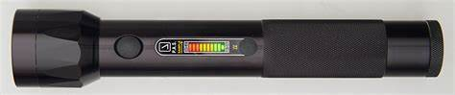

Figure : An image of a passive alcohol sensor

These sensors work by utilizing technologies such as fuel cell sensors, infrared spectroscopy, or semiconductor-based sensors to detect the presence of alcohol molecules. When alcohol vapors come into contact with the sensor, it produces a measurable response, indicating the presence and, in some cases, the approximate concentration of alcohol [6].

The shortcomings with this is the requirement of patrol stops for testing to be done. This brings about congestion if many vehicles are stopped on the road.

### 2.2 Proposed System

#### 2.2.1 Overview

The proposed system addresses the limitations of existing solutions by integrating multiple technologies. Firstly, the system incorporates image recognition technology to identify if the driver is under the influence of alcohol. Additionally, by integrating alcohol sensor technology into the system, accurate BAC measurements are obtained in real-time. GPS and GSM technologies are also used for accurate timing and locational functionalities to make alerts to the relevant people.

The proposed system uses raspberry pi microcontroller due to its image processing capabilities to do image processing of drivers’ faces to determine the intoxication levels.

**Benefits of the Proposed System**

1. Real-time monitoring and alerts: The integration of wireless communication and alert systems enables real-time monitoring of drivers. This allows the concerned party to take action in case the driver is intoxicated, thus preventing drunk driving.
2. Accurate determination of intoxication level: Employing both image recognition and breathalyzer technology raises accuracy of the system making it efficient.
3. Saves on time: Unlike previous methods that can lead to congestion in highways, this system prevents drunk drivers from even reaching highways. This saves time for other road users that might have been caught in traffic due to patrol stops.

* **Research Gaps**

The development of this system will help eliminate the inconsistencies of previous methods as explained in the literature above.

#### 2.2.2 Microcontroller

Raspberry Pi 3 Model B is a single-board computer (SBC), meaning it does not have the plug, program and play abilities like the Arduino board. An SBC is a functional computer with no expansion slots for peripheral functions or expansions built on a single printed circuit board (PCB). It has to go through the setup and initialization phase in order to install the operating system into the Raspberry Pi [8]. Raspberry Pi's higher processing power, memory, and extensive software ecosystem make it more suitable for complex image processing tasks, computer vision applications, and real-time image analysis. The following features make it suited for image processing (pi 3 model B) [8]:

1. A quad-core 1.2 GHz ARM Cortex-A53 processor provides a considerable amount of processing power for its size and cost. The Cortex-A53 is a 64-bit processor architecture capable of executing multiple instructions simultaneously and efficiently.
2. More memory (RAM) is available, which is beneficial for storing and manipulating larger images and running memory-intensive image processing algorithms.
3. Runs a full-fledged operating system (such as Raspberry Pi OS, based on Linux), which provides a wide range of software libraries, tools, and programming languages for image processing. This allows for easier integration with popular image processing libraries like OpenCV, which provide a wealth of functions for image manipulation, analysis, and computer vision.
4. A VideoCore IV GPU that supports graphics rendering, video decoding, and image processing and provides a visually appealing and responsive user interface.

#### 2.2.3 Sensors

**Alcohol Sensor**

An alcohol sensor, also known as a breathalyzer or alcohol breath tester, is a device designed to measure the alcohol concentration in a person's breath [9]. It is commonly used to determine if someone has consumed alcohol and to estimate their blood alcohol content (BAC) level.

Alcohol sensors typically work based on the principle of ethanol detection. When a person blows into the sensor, the alcohol molecules in their breath react with a chemical or electrochemical sensor element. This reaction generates an electrical signal that is proportional to the concentration of alcohol present [10].

There are different types of alcohol sensors available, including fuel cell sensors and semiconductor sensors. Fuel cell sensors are more accurate and are commonly used in professional-grade breathalyzers. Semiconductor sensors are less expensive and are often found in personal or consumer breathalyzer devices.

Alcohol sensors are widely used in various settings, such as law enforcement, workplace safety, and personal breathalyzer devices [9]. However, it's important to note that the accuracy of alcohol sensors can vary, and they should not be considered as a definitive measure of a person's intoxication level. Professional confirmation with blood or urine tests is typically required for legal or medical purposes.

In this project, MQ3 alcohol sensor will be used in order to offer accurate BAC reading of the driver’s breath.

**MQ3 Alcohol Sensor**

The MQ3 alcohol sensor is a popular type of gas sensor specifically designed to detect alcohol vapors in the air. It is widely used in various applications such as breathalyzers, automotive systems, safety devices, and industrial environments [11].

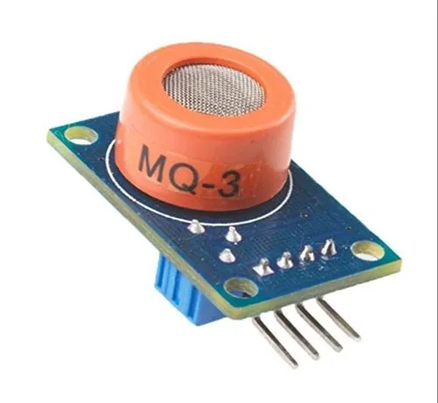

Figure : An MQ-3 alcohol sensor

The MQ3 sensor module consists of a sensing element, an integrated heater, and a signal conditioning circuit [11]. The sensing element utilizes a tin dioxide (SnO2) semiconductor material, which exhibits changes in its electrical conductivity when exposed to alcohol fumes.

**Pin Configuration and Structure**

The MQ3 alcohol sensor configuration and structure is as below. It is made up of 2 H-pins for supply and ground connection, 2 A-pins connected to the power supply, and 2 B-pins for output and ground connection. Pins A and B can be interchanged [11].

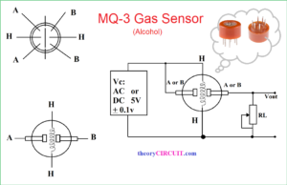

Figure : Pin Configuration of an alcohol sensor

The resistance of A and B varies based on the alcohol detection. The resistance of the sensor decreases as the level of alcohol concentration detection increases [11].

**MQ3 Pinout Diagram**

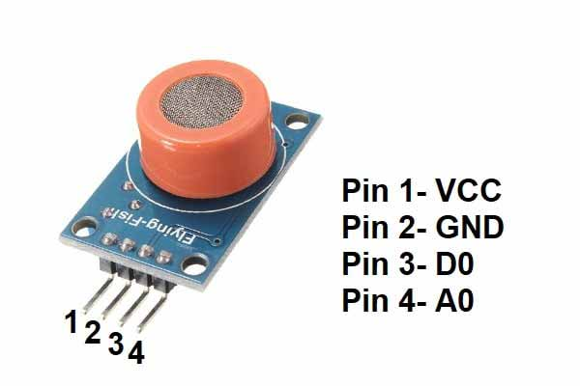

Figure : Pinout Diagram of an MQ-3 sensor

The sensor has four external pins;

* The VCC is the positive power supply where 5V is supplied to power the sensor.
* The GND is the common ground connection.
* The digital output (DO) generates digital output signals, 0 and 1, indicating different levels of intoxication.
* The analog output (AO) generates analog output signals, varying between 0V and 5V, depending on alcohol gas intensity.

**Working of the Sensor**

The operation of the MQ3 alcohol sensor involves the following steps [11]:

1. Heating: The sensor module includes a built-in heater that raises the temperature of the sensing element. This heating process ensures stable and accurate detection of alcohol vapor.
2. Gas Sensing: When the alcohol vapor is present in the air, it interacts with the heated sensing element. The alcohol molecules cause a change in the electrical resistance of the SnO2 material.
3. Signal Conditioning: The signal conditioning circuitry in the sensor module measures the resistance changes in the sensing element and converts them into an output voltage or digital signal.
4. Output: The output signal from the MQ3 sensor can be analog or digital, depending on the specific module. This signal is proportional to the alcohol concentration present in the environment.

This sensor achieves higher accuracy when measuring BAC level and thus will be employed in the project.

##### GPS Module

‌A GPS (Global Positioning System) module is a device that receives signals from multiple satellites to determine the precise geographical location of an object or person [12]. The GPS system consists of a network of satellites orbiting the Earth, which transmit signals containing information about their position and time. The GPS sensor receives these signals and calculates the distance between the satellites and the sensor based on the time it takes for the signals to reach it. By combining the signals from multiple satellites, the GPS sensor can triangulate its position on the Earth's surface with high accuracy.

GPS sensors are commonly used in various applications, including navigation systems in vehicles, smartphones, and wearable devices. They provide real-time location information, enabling users to determine their position, track movement, and navigate to specific destinations [13]. Additionally, GPS sensors can provide data such as speed, altitude, and heading, depending on the capabilities of the device incorporating the sensor.

**GPS Module for Raspberry pi**

A GPS module for Raspberry Pi is a hardware component that allows Raspberry Pi devices to receive and process signals from Global Positioning System (GPS) satellites. It provides the ability to determine precise location coordinates, altitude, speed, and time information [14].

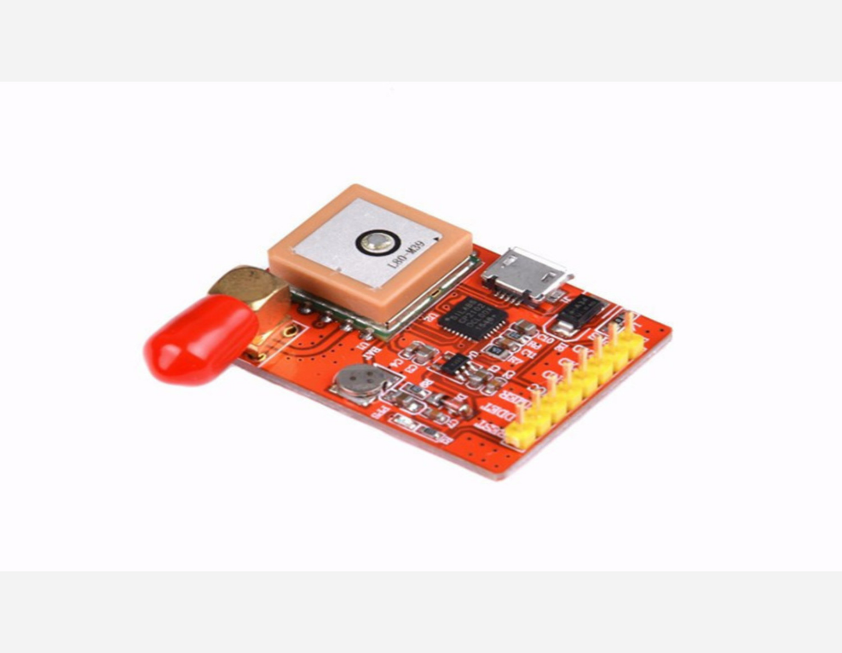

Figure : GPS module for Raspberry-Pi

A GPS module typically consists of a GPS receiver, an antenna, and an interface for connecting to the Raspberry Pi. The receiver captures signals transmitted by GPS satellites orbiting the Earth and calculates the device's position based on the data received. The antenna helps in capturing the GPS signals effectively [14].

**Working of the Sensor**

To connect a GPS module to a Raspberry Pi, you usually use the UART (Universal Asynchronous Receiver-Transmitter) interface or the serial communication interface. The module communicates with the Raspberry Pi via serial communication, providing the necessary GPS data for processing [15]. Once connected, you can access the GPS data from the module using programming languages like Python. By reading the GPS data, you can retrieve latitude, longitude, altitude, speed, and other information related to the device's position and movement.

GPS modules for Raspberry Pi are commonly used in projects that require precise location tracking, navigation, mapping, geolocation-based applications, and outdoor positioning systems. They can be utilized in applications such as vehicle tracking, asset monitoring, robotics, geocaching, and more. The GPS module adds a valuable geospatial capability to Raspberry Pi projects, enabling them to interact with the GPS network and leverage location-based functionalities.

This project shall utilize the capabilities of this module to develop a real-time alert system for monitoring drivers’ location and time.

##### GSM Module

GSM stands for Global System for Mobile Communications. A GSM module/ modem, is a device that integrates a GSM radio transceiver, allowing it to communicate over GSM networks [16]. GSM modules are typically used in various applications where wireless communication is required, such as remote monitoring, telemetry, tracking systems, and IoT (Internet of Things) devices [13]. These sensors are capable of sending and receiving data via SMS (Short Message Service) or GPRS (General Packet Radio Service) protocols over GSM networks [16]. They can be connected to a microcontroller or a computer system to enable remote communication and control.

GSM sensors are commonly used in industries like agriculture, transportation, security systems, and environmental monitoring. They enable real-time data transmission, remote control of devices, and the ability to receive alerts or notifications through SMS or data connections [16].

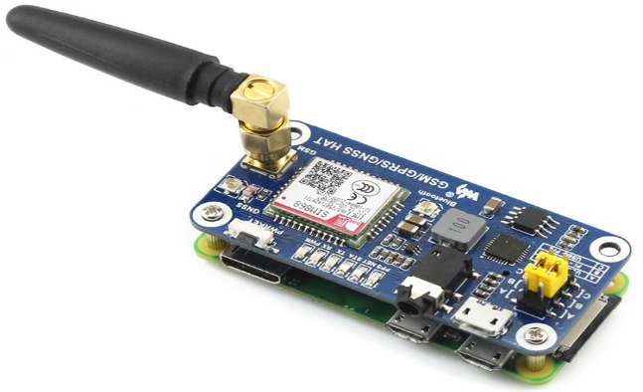**Raspberry Pi GSM Module**

Figure : GSM module for Raspberry Pi

The Raspberry Pi GSM module is an add-on module that allows Raspberry Pi devices to communicate over GSM (Global System for Mobile Communications) networks. It provides a way to add cellular connectivity to Raspberry Pi projects, enabling them to send and receive SMS messages, make voice calls, and access the internet via a GSM network [17].

The GSM module is based on the SIM800 series of GSM/GPRS modules developed by SIMCom. It supports quad-band GSM/GPRS frequencies, which means it can be used in various regions worldwide [14]. The module features a built-in SIM card slot where a valid SIM card from a GSM service provider is inserted to establish a cellular connection.

**Working of the Module**

To connect the GSM module to a Raspberry Pi, you typically use the UART (Universal Asynchronous Receiver-Transmitter) interface. The module communicates with the Raspberry Pi via serial communication, using AT commands to control its functionality [18]. The Raspberry Pi's GPIO pins are used to provide power and establish the serial communication connection with the module. Once the module is connected and powered, you can interact with it using programming languages like Python. By sending AT commands to the module via the Raspberry Pi, you can perform various operations such as sending SMS messages, making calls, and accessing internet services.

The Raspberry Pi GSM module is often used in projects that require remote communication capabilities or when an internet connection is not readily available. It can be used for applications like remote monitoring, IoT projects, home automation systems, and more, providing a wireless communication solution using the GSM network [19].

The features of this module conform to our objective of developing a real-time alert system for drivers.

#### 2.2.4 Machine Learning

Machine learning (ML) is the scientific study of algorithms and statistical models that computer systems use to perform a specific task without explicit instructions, relying on patterns and inference instead. It is seen as a subset of artificial intelligence. Machine learning algorithms build a mathematical model based on sample data, known as "training data", to make predictions or decisions without being explicitly programmed to perform the task [20]. Machine learning algorithms are used in various applications, such as email filtering and computer vision, where developing a conventional algorithm for effectively performing the task is infeasible. Machine learning algorithms can be divided into 3 classes; Supervised, Unsupervised, and Reinforcement Learning [20]. The supervised learning technique is further expounded to narrow the scope of study in an attempt to focus on relevance.

**Supervised Learning**

This machine learning job entails discovering a function that converts inputs into outputs using examples of input-output pairs [21]. From labeled training data made up of training instances, it infers a function. Each example in supervised learning is a pair made up of an input object, which is often a vector, and a desired output value, also known as the supervisory signal. An inferred function is generated by a supervised learning algorithm from the training data, which may then be used to map new examples [20]. The algorithm will be able to accurately identify the class labels for instances that aren't currently visible in an ideal circumstance. This necessitates that the learning algorithm generalize in a "reasonable" manner from the training data to hypothetical situations. Bioinformatics, cheminformatics, quantitative structure-activity relationship, database marketing, handwriting recognition, information retrieval, learning to rank, information extraction, object recognition in computer vision, optical character recognition, spam detection, pattern recognition, and speech recognition are just a few fields that use supervised learning [22].

Frameworks like PyTorch, TensorFlow, and the Microsoft Cognitive Toolkit are just a few of the solutions on the market to make machine learning development easier [21]. The preferred framework in this study is TensorFlow.

Classification, regression with k-nearest neighbor algorithms, support vector machines (SVM), random forests, linear regression, neural networks, decision trees, etc. are examples of supervised learning techniques [20]. SVMs are models that analyze data used for classification and regression analyses. The SVM model represents the examples in datasets as points in space mapped such that the examples of separate categories are divided by a clear gap [22].

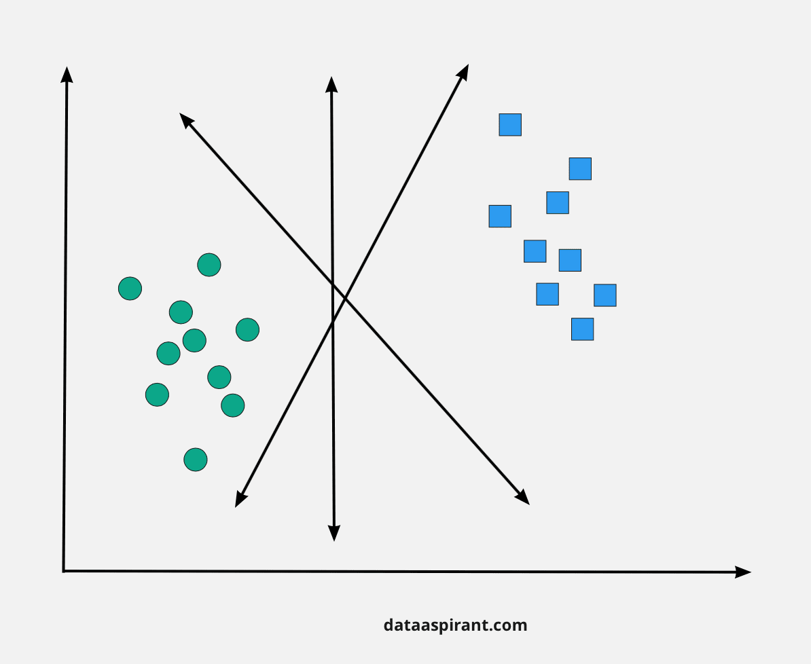

Figure : An example of the SVM model classifier

The arrows separate the round blue dots and the blue squares. This illustrates the operation of an SVM. Since the decision boundary is linear between classes, it cannot be applied in detecting sober and intoxicated drivers but is a good fit for differentiating between the two [22]. The K-nearest neighbor is suitable for classification and regression tasks and requires calculating distances between all test or predicting samples and all the training samples [20]. This makes it computationally expensive for use in image pattern recognition. Linear regression assumes a linear relationship between the input features and the target variables which nullifies its use in image pattern recognition [20]. Neural networks are the perfect algorithm to detect sober and intoxicated drivers as they can learn hierarchical features from raw pixel data with a non-linear decision boundary [20].

**Neural networks (NN)**

Neural networks are a subset of supervised machine learning techniques with robust algorithms and data structures that model problems. NNs have units (neurons) organized in a three layers category: input, hidden, and output layers. The hidden layer can be a single layer thus shallow NN or multi-layer thus deep NN (DNN) [23]. Shallow NN have a limited capacity to learn complex patterns or relations in data due to their single-layer structure [23]. DNNs’ multi-hidden layer allows for the learning of hierarchical features, capturing more complex relationships and patterns in the data making them effective for tasks involving complex and high-dimensional data such as image recognition [23].

In order to achieve high accuracy in prediction, there are two dependent problems: network architecture and training routine have to be addressed when solving problems with NNs [21]. Defining network architectures involves setting fine-grained details such as activation functions (e.g., hyperbolic tangent, rectified linear unit (ReLU), maxout) and the types of layers (e.g., fully connected, dropout, batch normalization, convolutional, pooling) as well as the overall architecture of the network [21]. Defining training routines involves setting the learning rate schedules (e.g., stepwise, exponential), the learning rules (e.g., stochastic gradient descent (SGD), SGD with momentum, root mean square propagation (RMSprop), Adam), the loss functions (e.g., MSE, categorical cross entropy), regularization techniques (e.g., L1/L2 weights decay, early stopping) and hyper-parameter optimization (e.g., grid search, random search, Bayesian guided search) [21].

**Deep Neural Networks**

Because DNNs have more hidden layers than shallow NNs, they are thought to be better able to learn complex and abstract high-level characteristics. Among the most well-liked architectural styles are:

1. ***Fully Connected Networks (FC):*** are used to model a wide variety of problems that use tabular data [21].
2. **Convolutional *Neural Networks (CNN):*** are networks specially designed to deal with images (or more generally with translation invariant data). Current applications include X-ray scans, image segmentation, autonomous driving, and satellite imagery [21].
3. ***Recurrent Neural Networks (RNN):*** are specially designed to deal with sequential data. They are widely used in Natural Language Processing (NLP) like Neural Machine Translation, language generation, time series analysis, medicine or climatology [21].
4. ***Generative Adversarial Networks (GAN):*** are networks that compete against themselves to create the most possible realistic data. Current applications include image style transfer, high resolution image synthesis, text-to-image synthesis, image super-resolution, anomaly detection, 3D object generation, music generation, and scientific simulations acceleration [21].

Therefore, CNN is the proposed architecture to be used for differentiating between the sober and intoxicated drivers.

**Support Vector Machines (SVMs)**

A hyperplane is employed by SVMs, a sort of supervised learning algorithm, to distinguish between two classes of data [24]. The hyperplane is selected to maximize the distance between it and the nearest points in each class. As a result, it is guaranteed that the SVM will correctly forecast new data points that are close to the decision border. The RGB values of the pixels in an image are typically the features used to train the SVM for color distinction. The SVM then learns to locate a hyperplane in RGB space that divides the two colors [24].

**TensorFlow**

Thanks to machine learning frameworks (such as Google’s TensorFlow) that ease the process of acquiring data, training models, serving predictions and refining future results. TensorFlow is an open-source library for numerical computation and large-scale machine learning. TensorFlow bundles together a slew of machine learning and deep learning (aka neural networking) models and algorithms and makes them useful using a common metaphor. It uses Python to provide a convenient front-end API for building applications with the framework while executing those applications in high-performance C++. TensorFlow can train and run deep neural networks for handwritten digit classification, image recognition, word embedding, recurrent neural networks, sequence-to-sequence models for machine translation, natural language processing, and PDE (partial differential equation) based simulations [21].

TensorFlow provides all of this for the programmer using the Python language. Python is easy to learn and work with and provides convenient ways to express how high-level abstractions can be coupled. Nodes and tensors in TensorFlow are Python objects, and TensorFlow applications are themselves Python [21].

The actual math operations, however, are not performed in Python. The transformations' libraries available through TensorFlow are written as high-performance C++ binaries. Python directs traffic between the pieces and provides high-level programming abstractions to hook them together [21].

TensorFlow applications can be run on almost any convenient target: a local machine, a cluster in the cloud, iOS and Android devices, CPUs, or GPUs. Using Google’s cloud, you can run TensorFlow on Google’s custom TensorFlow Processing Unit (TPU) silicon for further acceleration. The resulting models created by TensorFlow, though, can be deployed on most devices where they will serve predictions [21].

The single biggest benefit TensorFlow provides for machine learning development is an abstraction. Instead of dealing with the nitty-gritty details of implementing algorithms or figuring out proper ways to hitch the output of one function to the input of another, the developer can focus on the overall logic of the application. TensorFlow takes care of the details behind the scenes.

**TensorFlow vs the Competition**

There are also alternative machine learning frameworks with which TensorFlow competes. Three significant frameworks, PyTorch, CNTK (Cognitive Toolkit), and MXNet, all focus on similar issues. The advantages and areas where TensorFlow excel are outlined here [21].

Apart from being created with Python, PyTorch is quite similar to TensorFlow in terms of its hardware-accelerated internal components, highly interactive development methodology, and abundance of pre-built helpful components. In general, PyTorch is a superior option for quickly developing applications that must be operational quickly, whereas TensorFlow triumphs for larger projects and more intricate operations. It is safe to use a more dynamic framework, TensorFlow, as Signer is designed to be developed on an ever-changing and dynamic platform, with a limited understanding of the complexity of training models.

CNTK, the Microsoft Cognitive Toolkit, like TensorFlow, uses a graph structure to describe data flow but focuses most on creating deep learning neural networks. CNTK handles many neural network jobs faster and has broader APIs (Python, C++, C#, Java). But CNTK isn’t as easy to learn or deploy as TensorFlow [21].

Apache MXNet, adopted by Amazon as the premier deep learning framework on AWS, can scale almost linearly across multiple GPUs and machines. It also supports a broad range of language APIs—Python, C++, Scala, R, JavaScript, Julia, Perl, and Go—although its native APIs aren’t as pleasant to work with as those of TensorFlow [21].

Therefore, TensorFlow will hence be chosen as the machine learning framework herein. Concerning hardware components, the glove-based recognition system is composed of three main units: input, processing, and output.

**TensorFlow Lite**

A pre-trained model in TensorFlow is converted to a particular format in TensorFlow Lite that is optimized for performance or storage. TensorFlow Lite is an open-source, cross-platform, product-ready deep learning framework. To make the inference at the edge, the custom format model can be installed on edge devices like mobile phones utilizing Android or iOS or Linux-based embedded devices like Raspberry Pi or Microcontrollers [25].

TensorFlow Lite is made up of two main parts [25]:

The TensorFlow Lite converter transforms TensorFlow models into an efficient form for the interpreter and can introduce optimizations to improve binary size and performance.

The TensorFlow Lite interpreter runs specially optimized models on a variety of hardware types, such as mobile phones, embedded Linux devices, and microcontrollers.

The workflow for using TensorFlow Lite involves the following steps [25]:

1. ***Pick a model:*** Bring your own TensorFlow model, find one online, or pick one from our pre-trained models to drop in or retrain.

2. ***Convert the model:*** If you're using a custom model, use the TensorFlow Lite converter and a few lines of Python to convert it to the TensorFlow Lite format.

3. ***Deploy to your device:*** Run your model on-device with the TensorFlow Lite interpreter, with APIs in many languages.

4. ***Optimize your model:*** Use the Model Optimization Toolkit to reduce your model’s size and increase its efficiency with minimal impact on accuracy.

# CHAPTER 3: METHODS AND MATERIALS

## 3.1 Methods

## 3.1.1 ML DATASET Overview

### 3.1.1.1 Data collection & Pre-processing

A data set consisting of 2500 facial images from different processing stages from field surveys and Google images will be collected. The data set will be divided into drunk and sober faces.

#### 3.1.1.1.1 Proposed sources of data

##### Three Glasses Later

Marco Alberti, a Brazilian photographer and artist, photographed 53 different persons while sober and then after consuming one, two, and three glasses of wine [27]. The experiment, named 3 Glasses Later, attempted to highlight how people's personas changed as they drank and had a pleasant evening (see Figure 8). This dataset was not gathered scientifically and may exaggerate the subject's feelings in order to make the art piece more compelling. It does, however, provide clear photographs of individuals drinking with good lighting, frame, and quality. This data was used to assist test and train the accuracy of our technology, but it is not scientifically useful. While the uniform capture conditions of all photographs may be useful in the early stages of our application, real-world photos will feature off-centre faces, varied perspectives, lighting, and other characteristics that are not present in this dataset [28]. As a result, we will use picture augmentation to supplement our dataset with photographs that better reflect real-world settings.

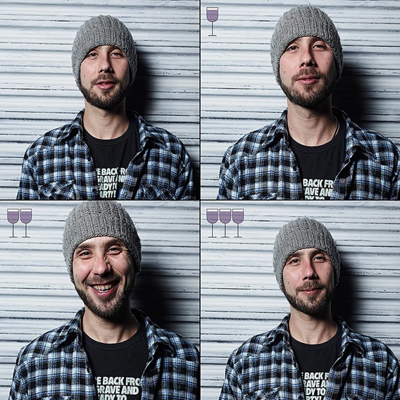

*Figure 8: Example photograph by Marco Alberti from Three Glasses Later collection*

***Characteristics of Images***

The images captured had similar characteristics and include the following:

1. Pixels – The images had 651 pixels width and 651 pixels height
2. Aspect Ratio – The images had an aspect ratio of 651/651
3. Background – The images background had an RGB colour rgb[230, 230, 230]

**Advantages of Three Glasses Later as a Data Source**

1. Each facial image has a known level of alcohol intoxication thus making it easy to spot the differences.
2. The collection of images provides a good foundation to help distinguish sober and drunk faces.

**Disadvantages**

1. The images in the dataset is not enough to train an accurate model

##### Social Media

Another source of photos of inebriated people is social media. Thousands of images of people have been tagged or labelled with the phrase "drunk selfie" on sites including Flickr, Imgur, Twitter, Instagram, Facebook, and Google. Because the lighting, framing, and quality of these photographs vary, they may be better for training our sobriety estimator for the actual world [28]. However, several of the images do not show people's faces, and it is impossible to tell how inebriated the subjects are in the photos.

Furthermore, these images are not coupled with the subject's sober photo, making spotting the difference between photos difficult. Subjects' reports may possibly include non-drunk images for comparison, although proving they were sober would be tough. As a result, we might decide against testing with photos from social networking outlets.

**Advantages**

1. Many images can be collected through social media pages.
2. Images from social media have a wide range of characteristics portraying real life settings i.e. blur images, extreme lighting.

**Disadvantages**

1. It is difficult to tell the level of drunkenness a face is from a collected image for training our model.

#### 3.1.1.1.2 Goals

The major goal of our project is to create a technology that can accurately classify drunkenness in photos of people's faces. We will concentrate on the following objectives to attain our goal:

1. Develop an image pipeline that extracts key features that indicate drunkenness
2. Determine which facial features most effectively classify a person’s drunkenness
3. Create a drunkenness classifier to accurately identify sobriety using the extracted features
4. Compare classifiers to optimize classification accuracy

To achieve these goals, we will employ a range of methodologies, including facial alignment, facial landmark detection, and pigmentation analysis, as detailed in the rest of this document. Our method is to result in an understanding of which face traits are most effective in determining a person's inebriation.

#### 3.1.1.1.3 Model Training and Evaluation

Convolutional Neural Network (CNN) architecture and the Adam optimizer with a batch size of 32 are used for model training and evaluation. CNNs use the Adam optimizer as one of its optimization algorithms [26]. A training set, a validation set, and a test set are typically created from the given data. The typical split looks like this:

1. ***Training Set:*** Eighty percent of the data are included in the training set. It is applied to deep learning model training. The model is exposed to the training set during training, and through backward and forward propagation, its parameters are modified based on the computed loss values.
2. ***Validation Set:*** 10% of the data are represented by this set. It is employed to keep track of the model's performance as it is being trained. Making judgments regarding the model's architecture and fine-tuning hyperparameters like learning rate and regularization strength are both aided by the validation set. Adjustments can be made to the model to improve its generalizability by assessing how well it performs on the validation set.
3. ***Test Set:*** Additionally, 10% of the data are contained in this set. The test set is used to assess the trained model's ultimate performance. It acts as an objective evaluation of how effectively the model generalizes to new data. To prevent bias and overfitting, the test set should be kept separate and not used during model training or hyper parameter adjustment.

The model's performance is evaluated and improved with the help of this partition of the data into training, validation, and test sets, guaranteeing that it can successfully generalize to new, unseen data.

The model will be trained for a total of 20 epochs (the number of times the complete training dataset will be run through the model throughout the training phase [26]), during which time loss values will be generated using forward propagation and learnable parameter updates will be made using back propagation using the Adam optimizer. The training process will be accelerated using GPU technology provided by Google Collab. The model's performance during training will be monitored, the hyperparameters will be adjusted, and model selection will be carried out using the validation set. At the very conclusion of the project, a test set will be utilized just once to assess how well the final CNN model performed after being adjusted and chosen based on the training and validation sets.

#### 3.1.1.1.4 Machine Learning Models

1. **Linear Support Vector Classifier**

A linear support vector classifier is a sort of SVM that classifies data points using mathematical models. Each data point is plotted in an N-dimensional space, where n is the number of features. In our situation, these data points are divided into four categories: sober, one drink, two drinks, and three drinks. Linear support vector classifiers employ data trends to discover the optimal way to segment each point into a solution space. The solution space is split using a hyperplane and the maximum margin best defines the output categories, see Figure 9.

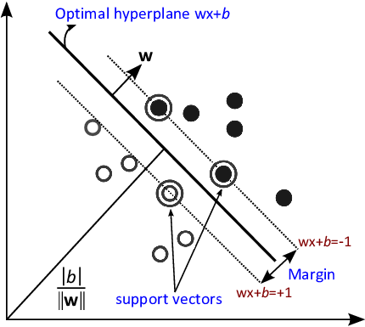

*Figure 9: A graphical representation of a linear support vector classifier*

1. **Polynomial SVC**

Polynomial support vector classifiers are SVMs that compute a separation plane in higher dimensional domains. Each data point is still plotted in N dimensions. Classification, on the other hand, can be more accurate because it is more directly related to the data. This is more adaptable than linear support vector classifiers because it can classify data that is difficult to separate using two-dimensional hyperplanes.

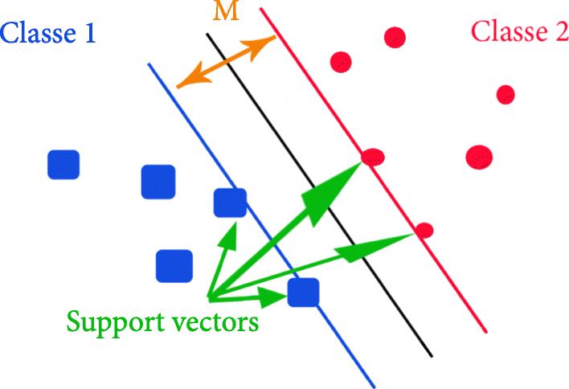

*Figure 10: Type of Support vector classifier [30]*

1. **Random Forest**

To assess the performance of decision-based tree models on our features, we will employ Random Forests learning. Random Forests is an implementation of the Decision Tree learning approach that employs randomness to prevent model overfitting [29]. The Decision Tree algorithm divides the input space into subspaces on a continuous basis. It does so by recognizing lines in the same way that the linear support vector classifier does, and when it recognizes unique regions inside the data, it classifies those regions as discrete categories.

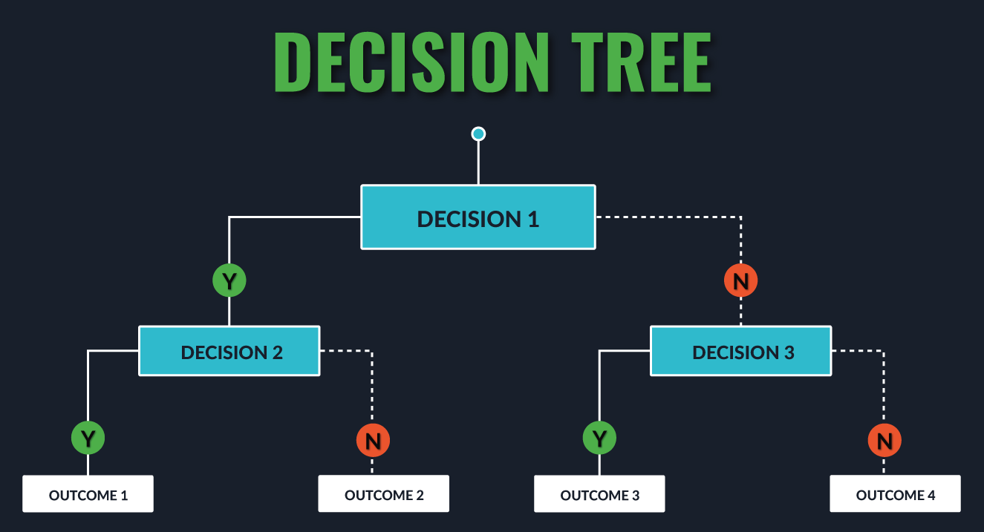

*Figure 11: An implementation of the decision tree with various depths*

Random Forests varies from the Decision Tree classifier in that it generates a collection of decision trees by randomly selecting data points, or subspaces, from the training set. It chooses these random samples and then builds a decision tree based on the provided feature set. The algorithm creates a tree with branches that lead to classifications: no drinks, one drink, two drinks, and three drinks. A decision is made to follow a specific path down the tree for each feature value. A certain combination of feature values will result in a specific output classification.

Having many decision trees allows for numerous versions of the core classification and produces a model that is less susceptible to noise. This is a robust approach to classify data that isn't always successfully categorized using linear support vector machines, although it has a tendency to overfit the test features. Random forests use the averages of decision trees trained on different portions of the test data.

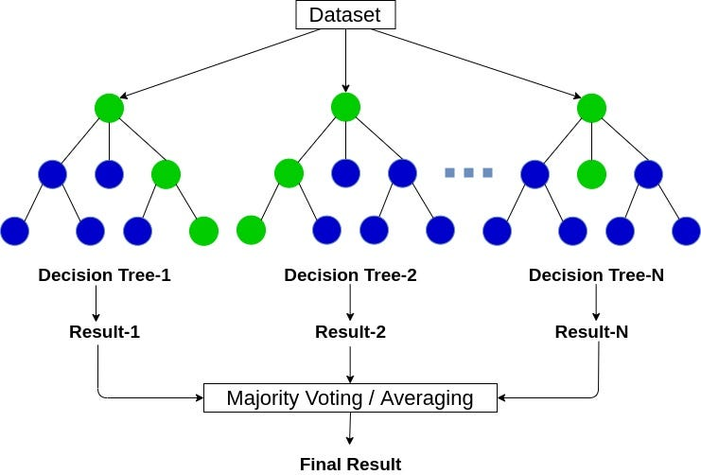

*Figure 12: Example of Random Forest Classification and Implementation*

#### 3.1.1.1.5 Machine Learning Intoxication Detection Pipeline

This project will aim to develop a pipeline of image operations performed on the 3 Glasses later dataset by Marco Alberti.

The proposed pipeline of image operations will include image detection and alignment, feature extraction and classification into either SOBER or DRUNK.

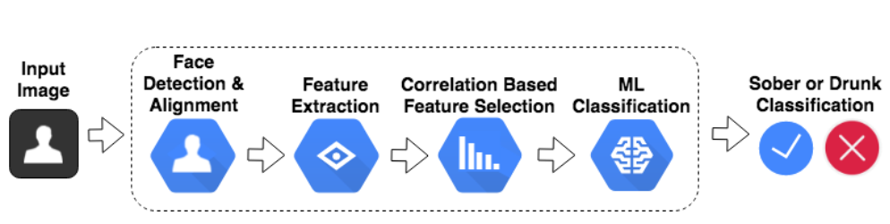

Figure : Machine learning Image classification pipeline

##### Face Detection

This process will involve identification of facial features once the driver’s image comes into the camera’s focus. The proposed method of Histograms of Oriented Gradients (HOG) – described in Navneet Dalal and Bill Triggs’ 2005 article- for detection of people in images is to be applied [31].

According to HOG, the photo is to be converted to a normalized level of colour and gamma values. Then the direction of gradients going from light to dark areas are identified and compared to other HOG patterns from a large dataset of facial images.

* **Locating facial features**

Once the face has been identified, areas of the face will be identified and labelled such as the eyes, mouth, nose, jawline etc.

The proposed method of identification of these facial features called Facial Landmarking developed by Vahid Kazemi and Josephine Sullivan in 2014 will be used [32].

Facial Landmarking algorithm involves placing 68 dots on the average location of facial features that will have been determined by sampling thousands of existing face images.

An Iterative process then morphs the shape of the points based on gradients in the image until the shape of the points matches the face’s shape as illustrated below;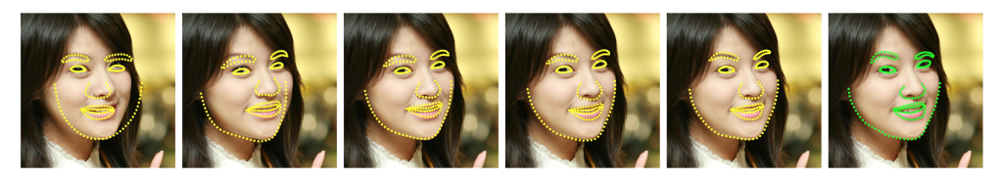

Figure :Feature estimates at different iterations of Facial Landmark algorithm

* **Face alignment (Using facial features)**

The features detected from the preceding step will allow the images to be rotated and aligned in a more standard form.

Alignment of images slightly turned will be done by warping the images based on their features to fit standard landmark locations.

Rotation and centering will be done by taking the center point between the eyes and then rotates, scales and crops the image to make it uniform.

Photo alignment allows for a standard input of faces to be used in the drunkenness estimator model.

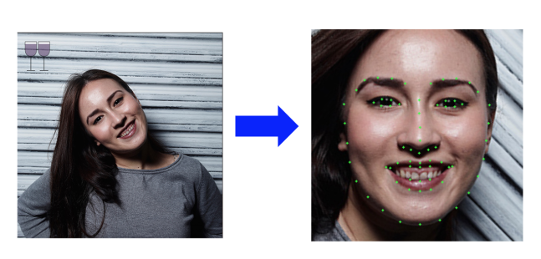

Figure : Facial alignment result

##### Features

* **Feature positions**

The facial features are considered to be the points on the face that show the most significant changes.

The facial landmarks are the key points on the face that express position of the following parts of the face:

* Left and right eyebrow
* Left and right eye
* Nose
* Jaw
* Mouth

Dlib library’s built-in facial detection tool is to be used to find landmarks in the photos. The changes in the facial structure and shape will then be analysed for potential indicators for drunkenness. Machine learning classifiers will be used to quantitively measure these changes as opposed to visually looking through.

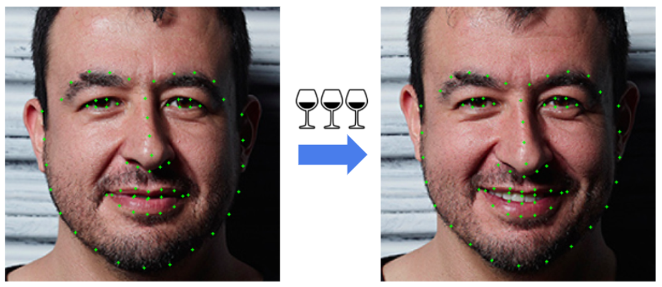

Figure :Landmark changes after intoxication

Confusion matrices are to be implemented to reveal how often a classifier predicts a label for category in question. Such matrices will allow for identification where the model is incorrectly identifying the alcohol consumption levels.

* **Feature vectors**

In a bid to increase classification accuracy, vectors generated from facial landmarks may be integrated in order to increase the accuracy in emotion detection.

This feature set will be implemented by drawing vectors from the central point of the face and the distance between the points and angle of the vector used as new features.

* **Landmark lines**

Here, the concept of connecting lines between landmarks to outline regions of the face is used. This focuses then on how the distance between the facial landmarks is affected when one is intoxicated.

This once again is proposed to help increase the model’s accuracy.

This method is to target areas of the subject’s face that are projected to undergo more profound changes if drunk such as shape of the mouth, eyes and cheeks.

##### Image Augmentation

This section will involve expanding the existing dataset of images to accommodate additional characteristics to the images in order to mirror real life photos. Such characteristics will include blur images, poor lit images, washed out, rotated, tinted and skewed images.

***Image Augmentation Implementation in Python with imgaug***

An open-source python library called imgaug can be used in order to apply such modifications to the images. The library has many common image augmentations implemented allowing the user to select the type of augmentation to implement on the photo dataset.

The named library supports augmentations such as image rotation, image brightening, image blurring, perspective change and tint addition.

With this feature, creation of several variations to one original image will allow to create more real-life scenario images that will better train the model to classify the subject’s drunkenness.

Illustrations of such augmentations are shown below:

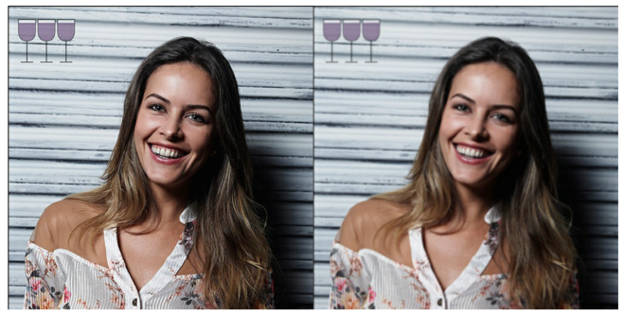

Figure : Gaussian blur

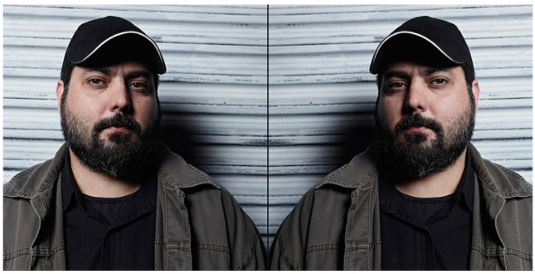

Figure : Perspective change

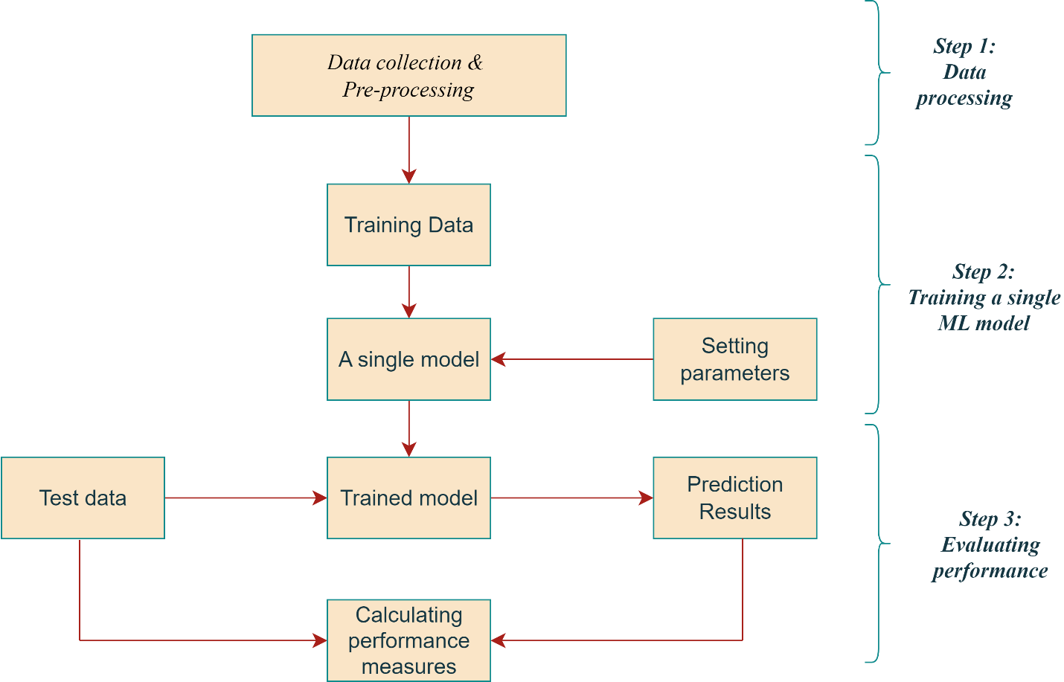

Figure : Machine learning model development

#### 3.1.1.1.6 Integration with Trained model and deployment

This process will involve the following steps:

* Convert the Model to TensorFlow Lite Format (. tflite) using TensorFlow Lite Converter to optimize the model for deployment on the resource-constrained Raspberry Pi.
* Transfer the Model to the Raspberry Pi using SCP (Secure Copy) to copy the model file from the training machine to the Raspberry Pi.
* Install TensorFlow Lite on the Raspberry Pi to provide the runtime environment for running the model.
* Load and Run the TensorFlow Lite Model on the Raspberry Pi code using the TensorFlow Lite Interpreter.
* Deploy and Integrate the Model by building the necessary logic around the TensorFlow Lite model to integrate the Raspberry Pi application which involves capturing input data (images from a camera), feeding it into the model for inference, and processing the output for further actions.
* Optimize for Raspberry Pi Performance to ensure efficient performance on the device. This could involves optimizing the code for better speed and memory usage.

## 3.1.2 System Operation

### 3.1.2.1 Raspberry Pi microcontroller unit

This is the brain of the system that is to take in inputs from the camera and alcohol sensor units and produce outputs to be used for controlling ignition system and sending cellular communication via the GSM technology. The main function of this unit will be to hold and provide processing power for the Machine learning algorithm expounded upon previously.

### 3.1.2.2 Camera unit

An infrared camera placed strategically in the steering wheel area will capture images of the subject’s face which will be transmitted to the Raspberry Pi microcontroller via wired connection.

### 3.1.2.3 Alcohol sensor unit

This unit will take driver’s breath samples which will be used to come up with an accurate figure of the subject’s BAC. The results will be transmitted to the microcontroller for processing and analysis.

### 3.1.2.4 Output system

For our system, the output will be modelled using RGB LEDs of different colours. Two colours (Green and Red) are preferred: Green to indicate the vehicle is allowed to proceed while Red indicating the vehicle stops.

### 3.1.2.5 Communication sub-system

This subsystem will comprise of the;

* GPS which will provide real-time location information through satellite communication and feed to the microcontroller.
* GSM that will provide cellular communication capabilities to the microcontroller enabling sending SMS to the authorities about the drivers’ condition and location.

### 3.1.2.6 Power unit

Will be made up of a 9V rechargeable battery and a voltage regulator. The battery will serve as the main power source to the modelled system and the voltage regulator will regulate the power supplied to each component in the system.

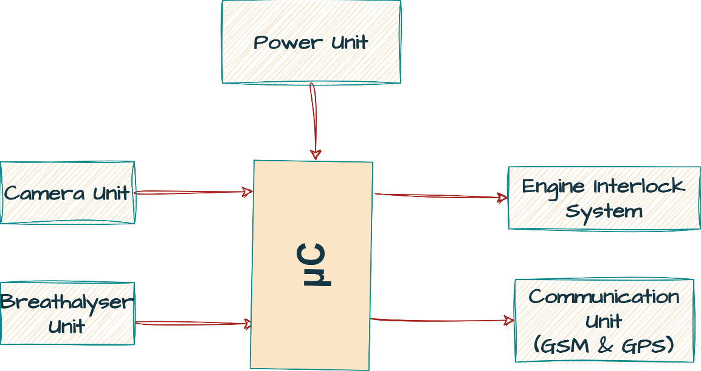

Figure 20:System block diagram

## 3.1.3 System operation flow

At the start of the system, the engine is off, the infrared camera detects and takes an image of the driver while the MQ3 alcohol sensor simultaneously takes samples of his/her breath. The data from the camera is to be processed in the microcontroller (with the help of an image recognition algorithm) to determine if the driver is ‘SOBER’ or ‘DRUNK’. If ‘DRUNK’, the sensor output is used to process the extent of intoxication. If it exceeds the legal limit (0.08% BAC), the driver is to be alerted, engine ignition impeded and cellular communication made concurrently. Otherwise, the ignition system starts normally.

The system is to give a delay before carrying out another alcohol test if previous result was ‘DRUNK’ – above legal limit.

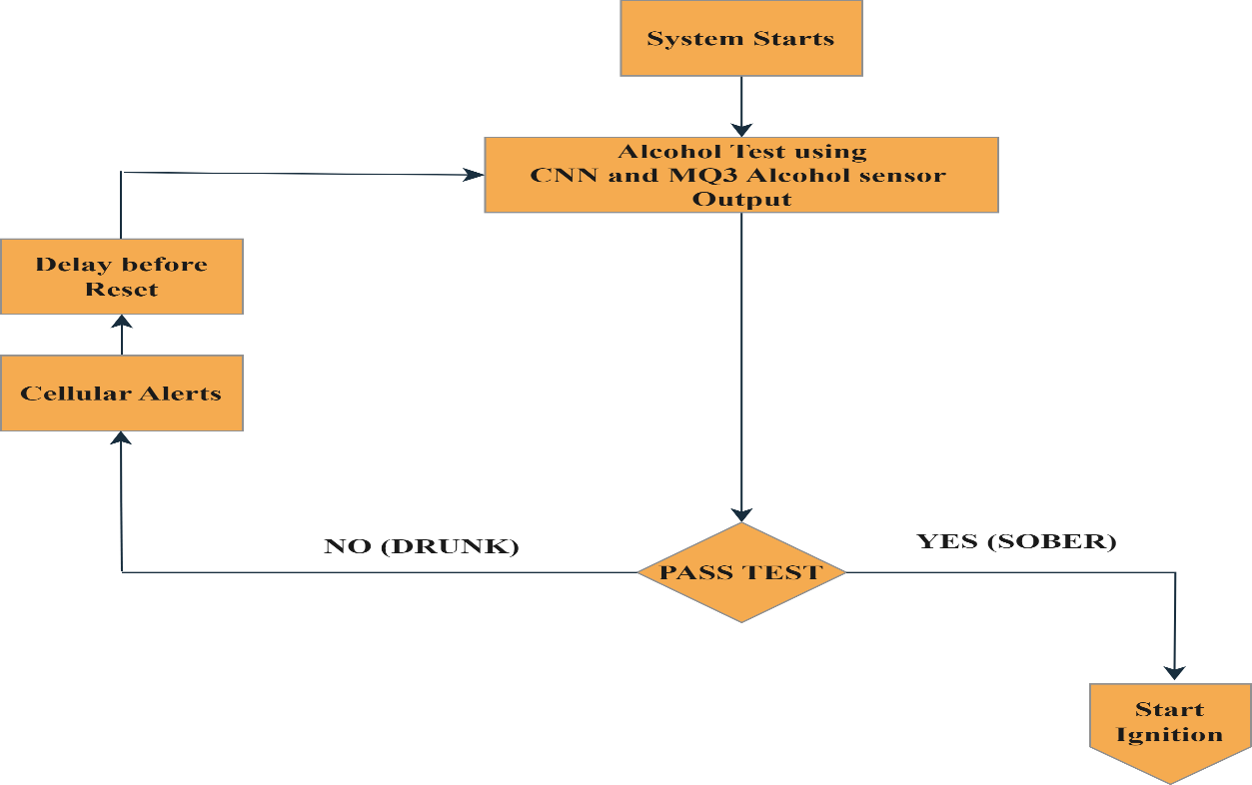

Figure : System flow diagram

## 3.2 Materials

Table : Table showing materials needed for the project

|  |  |  |  |
| --- | --- | --- | --- |
| No. | Equipment Diagram | Name | Brief Description |
| 1. |  | MQ3 Alcohol sensor | Response time at 23 degrees Celsius is 10s.  -40 – 60 degrees Celsius for storage temperature range.  Max ethanol concentration of 300/100ml air. |
| 2. |  | Raspberry Pi microcontroller | 2 USB 3.0 ports and 2 USB 2.0 ports  40 standard GPIO header. Micro-SD card slot for loading OS. 2-lane MIPI CSI camera port  2.4 GHz and 5.0 GHz IEEE 802.11ac wireless, Bluetooth 5.0, BLE. OpenGL ES 3.1, Vulkan 1.0 |
| 3. |  | GPS module for Raspberry Pi | NMEA, UBX Binary, RTCM communication protocols. |
| 4. |  | GSM module for Raspberry Pi | Embedded powerful TCP/IP protocol stack Quadband GSM/GPRS module |
| 5. |  | Cellphone | Fitted with local SP’s SIM card for communication from the GSM module |
| 6. |  | IR camera | Far infrared thermal sensor array, 32x24 pixels. Onboard voltage translator, compatible with 3.3V/5V operating voltage. Communicating via I2C interface, configurable to fast mode. |

# CHAPTER FOUR: EXPECTED RESULTS AND DISCUSSION

## 4.1 Expected Results

## 4.1.1 ML Development

The images from the 3 Glasses Later will help develop the machine learning model. The model will classify images from the original 3 Glasses Later and the augmented dataset as either sober (0-1 drinks) or not sober (2-3 drinks). Images used in the training set will be different from those in the testing set in order to achieve a higher accuracy.

Table : Sober and Drunk Decision

|  |  |
| --- | --- |
| **Number of Drinks** | **ML Decision** |
| 0-1 drinks | Sober |
| 2-3 drinks | Drunk |

## 4.1.2 ML Model Accuracy

The use of several features such as landmark points, vectors and lines will improve the model accuracy to above 90 percent. With a 90% accuracy the system will ensure no errors in the output.

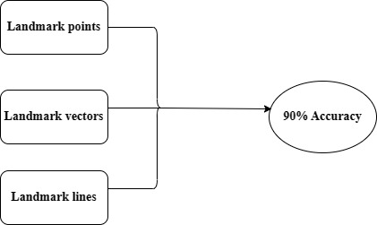

Figure : Combination of features to achieve higher accuracy

## 

## 4.1.3 Alcohol Sensor Unit

A proper calibration mechanism will be used to ensure the MQ-3 sensor has high accuracy levels.

Table : How MQ-3 makes decisions

|  |  |
| --- | --- |
| **Alcohol level** | **Decision** |
| Below 0.35g/liter of breath | Sober |
| Above 0.35g/ liter of breath | Drunk |

## 4.1.4 Output System

The decision of the ML unit and the alcohol sensor unit is fed to the output system.

The expectation is that the Green LED turns ON when the decision is Sober and the Red LED turns ON after a Drunk decision. Both LEDs should be OFF if no input is fed to the system.

Table : Operation of the Output System

|  |  |
| --- | --- |
| **Decision** | **Output** |
| Sober | Green LED turns ON |
| Drunk | Red LED turns ON |

## 4.2 Discussion

The combination of the landmark features in a Random Forest Classifier will be able to produce an accuracy of above 90 percent at correctly classifying photographs as drunk or sober. The appropriate calibration mechanism will enable to increase accuracy of the alcohol sensor. The output of the sensor will be able to show the extent of drunkenness of a driver. The output system, which is directly controlled by the decisions of the machine learning algorithm and the MQ-3 sensor, provides the results as either green or red lights.

The findings from the research study definitely will help in achieving the stated objectives in the introduction.

# CHAPTER FIVE: CONCLUSION

Impaired driving is a growing concern in the country and accounts for one third of all traffic-related deaths in the Kenya according to NTSA [33]. With the changes in technology, there is a necessity to adopt to modern ways of preventing road accidents that occur due to consumption of excessive alcohol. The project addresses this problem by using a machine learning algorithm to determine the sobriety of the user together with the alcohol sensor to determine the extent of intoxication. Analyzing the 53 subjects in Marco Alberti’s 3 Glasses Later dataset, we will be able to identify what features most accurately indicate drunkenness. Furthermore, using a combination of facial landmarks, vectors, and facial structures will yield the best results, helping us achieve an accuracy of 90 percent or higher. The integration of the GPS and GSM modules ensure that communication is made to the concerned parties in case the driver is intoxicated.

A system can therefore be developed incorporating these technologies to determine the sobriety state of a driver, and make the right decision concerning starting a vehicle.

# REFERENCES

[1] P. G. Miller, A. Curtis, A. Sønderlund, A. Day, and N. Droste, “Effectiveness of interventions for convicted DUI offenders in reducing recidivism: a systematic review of the peer-reviewed scientific literature,” *The American Journal of Drug and Alcohol Abuse*, vol. 41, no. 1, pp. 16–29, Oct. 2014, doi:<https://doi.org/10.3109/00952990.2014.966199>.

[2]“Sobriety Checkpoints | Transportation Safety | Injury Center | CDC,” *www.cdc.gov*, Mar. 02, 2022. https://www.cdc.gov/transportationsafety/calculator/factsheet/checkpoints.html#SnippetTab (accessed Jul. 10, 2023).

‌[3]Yik Lung Then, “Low-Cost Breathalyzer Ignition Interlock,” May 2015. ‌

[4] David Stanley Kinnamon, *Development of a Wearable Electrochemical Biosensor for Alcohol Consumption Monitoring*. 2016.

[5]“Passive Sensor Flashlight Overview & FAQs Passive Alcohol Sensors What are passive alcohol sensors? How do passive alcohol sensors collect participants’ breath without their active cooperation?” Available: https://publichealth.hsc.wvu.edu/media/2790/pas.pdf

‌[6]S. B. Karch, *Forensic Issues in Alcohol Testing*. CRC Press, 2016.

[7]A. Wayne Jones, Jorg Gustav Morland, and R. H. Liu, *Alcohol, Drugs, and Impaired Driving*. CRC Press, 2020.

‌[8] A. Pajankar, Raspberry Pi Image Processing Programming Develop Real-Life Examples with Python, Pillow, and Scipy. Berkeley, CA: Apress, 2017.

[9]A. Ganesh, *A Practical Approach to Alcoholism*. Lulu Press, Inc, 2015.

‌[10]N. Droste *et al.*, “Comparing levels of blood alcohol concentration and indicators of impairment in nightlife patrons,” *Drug and Alcohol Review*, vol. 37, pp. S348–S356, Dec. 2017, doi: https://doi.org/10.1111/dar.12639.

‌[11]T. Agarwal, “MQ3 Alcohol Sensor : Datasheet , Working & Its Applications,” *ElProCus - Electronic Projects for Engineering Students*, Jun. 13, 2022. https://www.elprocus.com/mq3-alcohol-sensor/

‌[12]J. A. Farrell, *Aided Navigation: GPS with High Rate Sensors*. McGraw Hill Professional, 2008.

‌[13]Franjieh El Khoury and A. Zgheib, *Building a Dedicated GSM GPS Module Tracking System for Fleet Management*. CRC Press, 2018.

[14]Anbazhagan K, *Raspberry Pi Telegram Bot, GPS Module, Flex Sensor, Line Follower Robot, Infrared Sensor, Smart Phone Controlled Home Automation, Motion Sensor*. 2019.

‌[15]T. Klosowski, *Raspberry Pi*. Penguin, 2015.

‌[16]Marc Pàmies Massip, *GSM Sensor*. 2017.

‌‌[17]Sami and Kisheen Rao Gsangaya, *The Internet of Mechanical Things*. CRC Press, 2022.

‌[18]A. K. Somani, Rajveer Singh Shekhawat, Ankit Mundra, S. Srivastava, and Vivek Kumar Verma, *Smart Systems and IoT: Innovations in Computing*. Springer Nature, 2019.

‌[19] Liberios Vokorokos, Matus Uchnar, and E. Pietrikova, “The Raspberry Pi in an Education Process,” May 2018, doi: https://doi.org/10.1109/saci.2018.8440999.

‌[20] C. M. Bishop, *Pattern Recognition and Machine Learning*. New York, NY: Springer New York, 2016.

[21] G. Nguyen et al., “Machine learning and deep learning frameworks and libraries for large-scale data mining: A survey,” Artificial Intelligence Review, vol. 52, no. 1, pp. 77–124, 2019. doi:10.1007/s10462-018-09679-z

[22] W. S. Noble, “What is a support vector machine?,” Nature Biotechnology, vol. 24, no. 12, pp. 1565–1567, 2006. doi:10.1038/nbt1206-1565

[23] S. J. Russell, P. Norvig, and E. Davis, Artificial Intelligence: A Modern Approach, 4th ed. Harlow, England: Pearson Educación, 2022.

[24]Ingo Steinwart, *Support vector machines.* Springer, 2014.

‌[25] “TensorFlow Lite,” TensorFlow, https://www.tensorflow.org/lite/guide (accessed Jun. 30, 2023).

[26] M. A. Nielsen, Neural Networks and Deep Learning. Determination Press, 2015.

[27] M. Alberti, "3 Glasses Later," 2015. [Online]. Available: https://www.masmorrastudio.com/wine-project. [Accessed July. 29, 2023].

[28] Rein-Lien Hsu, M. Abdel-Mottaleb and A. K. Jain, "Face detection in color images," IEEE Transactions on Pattern Analysis and Machine Intelligence, vol. 24, pp. 696-706, 2002.

[29] L. Breiman, "Random forests," Mach.Learning, vol. 45, pp. 5-32, 2001.

[30] Pedregosa, "Scikit-learn: Machine Learning in Python," JMLR vol. 12, 2011.

[31] B. Başa, "Implementation of Hog Edge Detection Algorithm On fpga's," Procedia - Social and Behavioral Sciences, vol. 174, pp. 1567-1575, 2015.

[32] V. Kazemi and J. Sullivan, "One millisecond face alignment with an ensemble of regression trees," Proceedings of the IEEE Conference on Computer Vision and Pattern Recognition, pp. 1867-1874, 2014.

[33]“NTSA: More Kenyans have died in road accidents in 2021 compared to last year,” *Nation*, Dec. 20, 2021. https://nation.africa/kenya/news/ntsa-more-kenyans-have-died-in-road-accidents-in-2021-compared-to-last-year-3658854